**Keyperson policy**

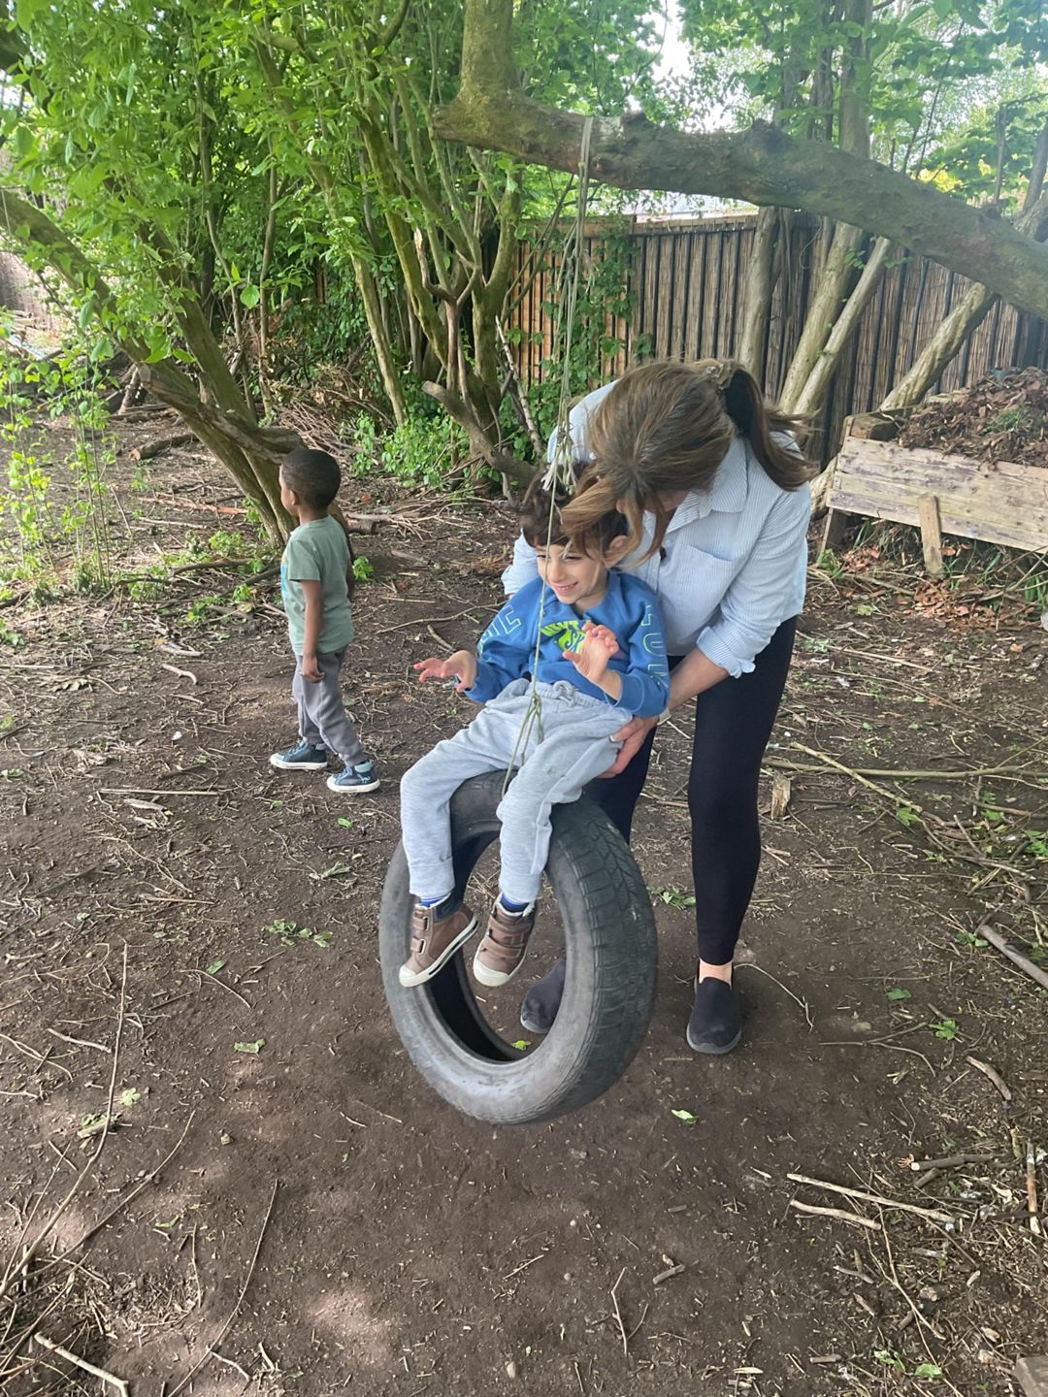We believe that children settle best when they have a key person to relate to, who knows them and their parents well, and who can meet their individual needs. Research shows that a key person approach benefits the child, the parents, the staff, and the setting by providing secure relationships in which children thrive, parents have confidence, staff are committed, and the setting is a happy and dedicated place to attend or work in. We want children to feel safe, stimulated, and happy in the setting and to feel secure and comfortable with staff. We also want parents to have confidence in both their children's well-being and their role as active partners with the setting. We aim to make the setting a welcoming place where children settle quickly and easily because consideration has been given to the individual needs and circumstances of children and their families. They key person role is set out in the Welfare Requirements of the Early Years Foundation Stage. The procedures set out a model for developing a key person approach that promotes effective and positive relationships for children who are in the setting. Procedures

• We allocate a key person before the child starts

. • The key person is responsible for the induction of the family and for settling the child into our setting.

• The key person offers unconditional regard for the child and is non-judgemental.

• The key person works with the parent to plan and deliver a personalised plan for the child’s well-being, care and leaning

. • The key person acts as the key contact for the parents and has links with other carers involved with the child, such as a child-minder, and coordinates the sharing of appropriate information about the child’s development with those carers.

• A key person is responsible for developmental records and for sharing information on a regular basis with the child’s parents to keep those records up to date, reflecting the full picture of the child in our setting and at home. At Best friend’s day nursery, staff ensure that they know all the children well and build relationships with them and their families so we can provide support in the absence of a child’s key person Key person Responsibilities The primary aim of the key person system is to provide close relationships between the practitioner and the child for whom the key person is responsible, and the parents /carers of those children in order to assist the development of the children. It is important to distinguish between the administrative aspects of a key worker system and the development of an appropriate key person relationship and to recognise the value of both aspects of the key person role. Aspects of a key person relationship are:

• Developing secure trusting relationships with key children and their parents.

• Interacting with key children at a developmentally appropriate level (e.g., when working with young babies using babbling sounds, facial expressions, and gestures.)

• Providing a secure base for your key children by supporting their interests and explorations away from you.

• Providing a secure base for your key children by being physically and emotionally available to them to come back to, by sitting at their level and in close proximity to them.

• Using body language, eye contact and voice tone to indicate that you are available and interested, gauging these according to the child’s temperament and culture.

• Understanding and containing children’s difficult feelings by gentle holding, providing words for feelings and empathy in a way suited to each individual child

.• Comforting distressed children by acknowledging their feelings, offering explanations and reassurances calmly and gently.

• Acknowledging and allowing children to express a range of feelings, for example, anger, joy, distress, excitement, jealousy, love.

• Settling new key children into the setting gradually.

• Whenever possible settles key children as they arrive each day.

• Sitting and eating with your key children, when possible

• Holding key children who are bottle –fed on your laps to feed, maintaining eye contact and conversation.

• Changing and other personal care of your key child using sensitive handling and words that are familiar to them.

• Dressing and washing your key children, offering help as needed but also building independence.

Created January 2016

Reviewed every year